# Screen Shots:

**Kick-off Meeting**

**6/18- ADS Kick-off Meeting/ Start developing Prototype Requirements/ Storyboards:**

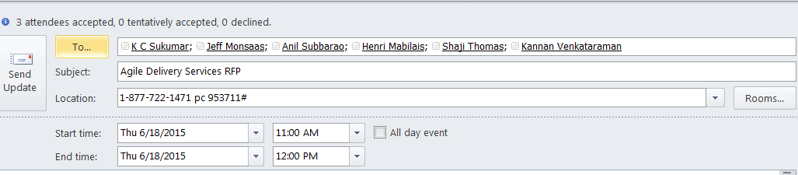

**Outlook Appointments for standup meetings**

**GSA Agile Delivery Services/ (FDA) Prototype Development Review Meetings start 6/18/2015  and ending 7/7/2015**

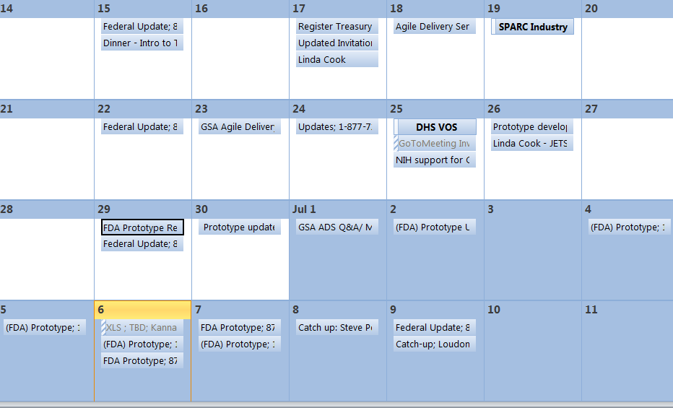

**6/26 – Application Development Requirements ; Coding start 7/2/15**

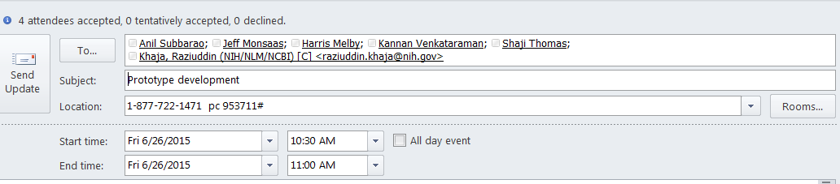

**Application Development**: Showing stages of progress (before and after)

7/5/2015

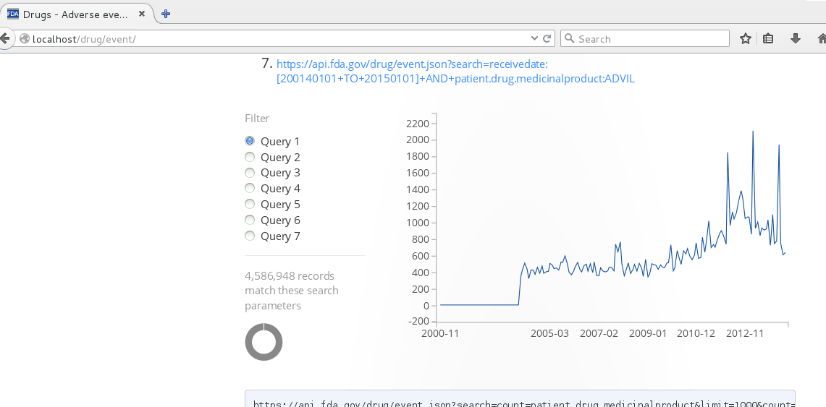

7/6/2015

